Manual blending operating instructions

This software application provides three major functions including warp, edge blending and black level correction.

※ If the application is already installed, please remove previous versions before installing the new one.
※ If the projector was powered off, please reopen the AP again to continue adjust once the projector is turned back on.

New Multi-Function

This function enables adjustment of each projector.
You can add new projectors using this function in the menu,【File】→【New Multi-Function】.

If you want to connect additional projectors, please select【File】→【New Multi-Function】again. You can use the mouse to select the projector which you want to adjust.
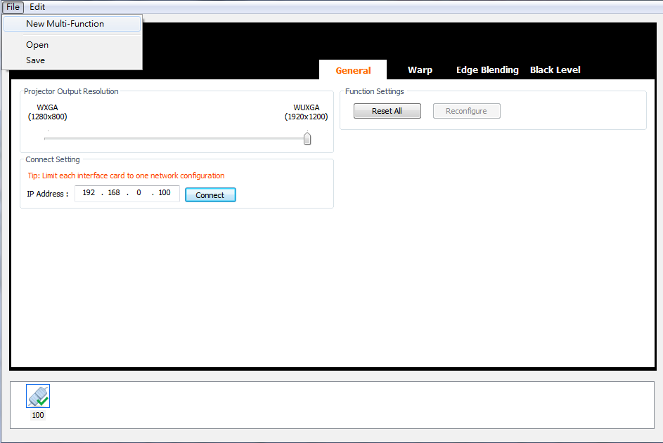

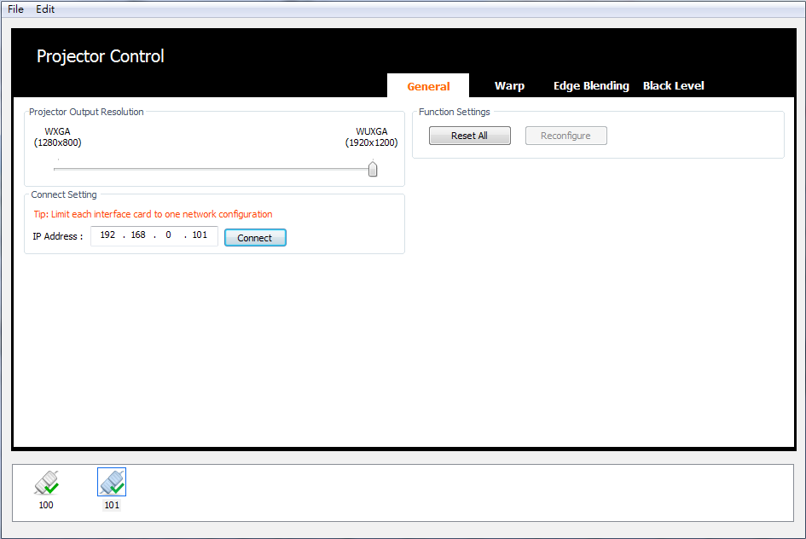

Switch Projector

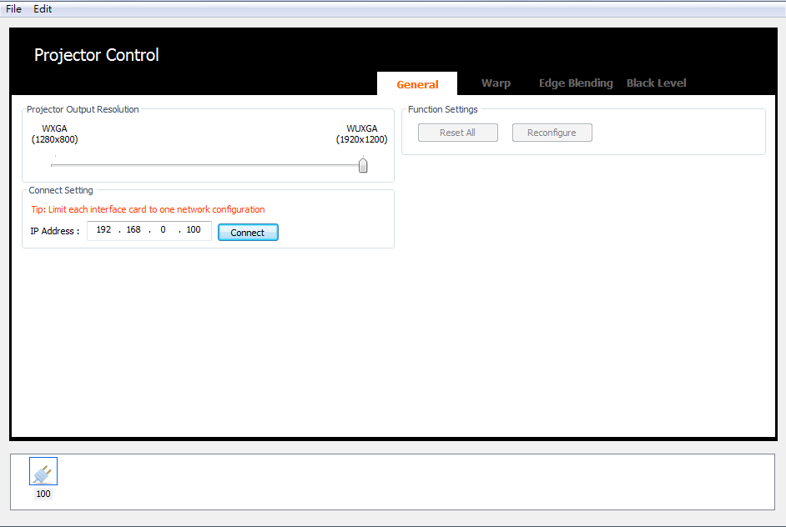
● Icon indicating projector communication is disconnected:

● Icon indicating projector channel is connected:

● Icon indicating projector channel is in sleep mode:

● The currently selected channel will be shown in a blue box:

● Press “Ctrl + Shift + Delete” on the keyboard to delete the selected channel

1

2

1. Change projector output resolution (per channel)
2. Edit IP address and connect with projector
※ Click on “Reset All” to apply default settings to projector
Click on “Reconfigure” to apply the current AP settings to projector

3

4
1

2

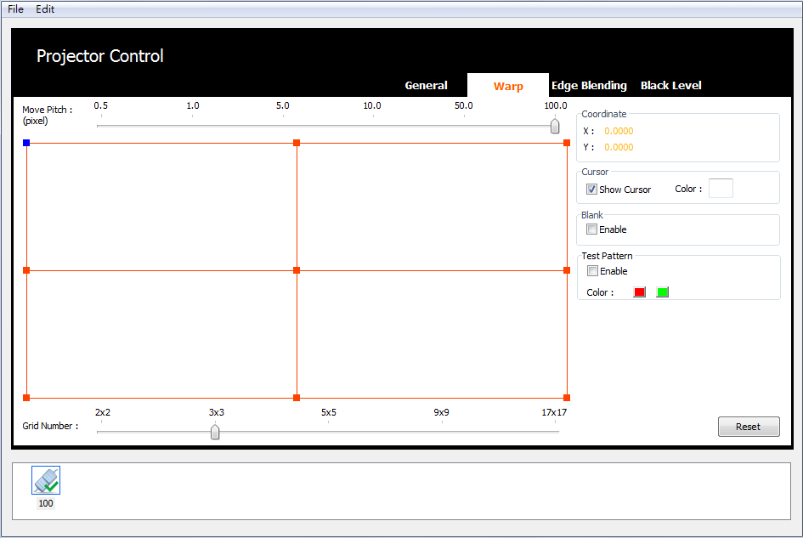
1. Change cursor color
Right click on the 【Color】 to change the cursor color
2. Adjust the Grid Number
Use 【Ctrl】and【+】, 【Ctrl】and【-】on the key board or simply use mouse to
increase/decrease the grid number, and to increase/decrease the cursor number at the same time.
3. Adjust the Move Pitch, use 【+】and【-】on the key board or simply use mouse.

4. Select Cursor, use【W】【,
A】,【S】,【D】on the key board or simply use mouse. The

selected cursor will be change into blue color.
5. Move cursor, use 【⬆】, 【⬇】, 【⬅】, 【➔】on the key board.

Adjustment procedure:
※ At first choose less grid numbers then increase the grid numbers step by step, so use 2x2 to setup four corners at first.
※ When using more grid numbers if you then go back to less grid numbers the earlier settings will be lost.
※ Adjust the outer cursors as the red ones shown below, and then adjust the inner
cursors as the green ones shown below.
※ After adjusted inner cursors then adjusted outer cursors will lose the inner
cursors settings.

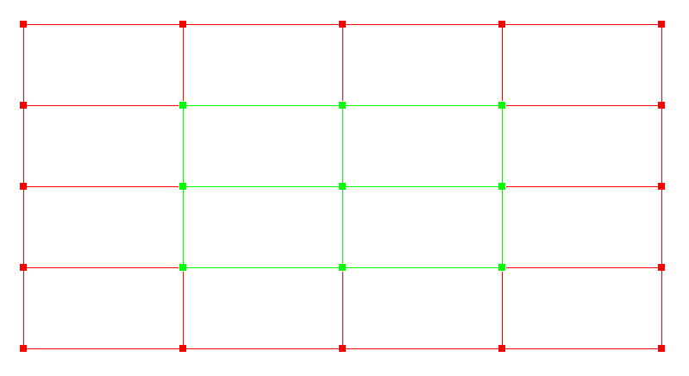

Test Pattern
Use test pattern to speed up the warping process as shown below.

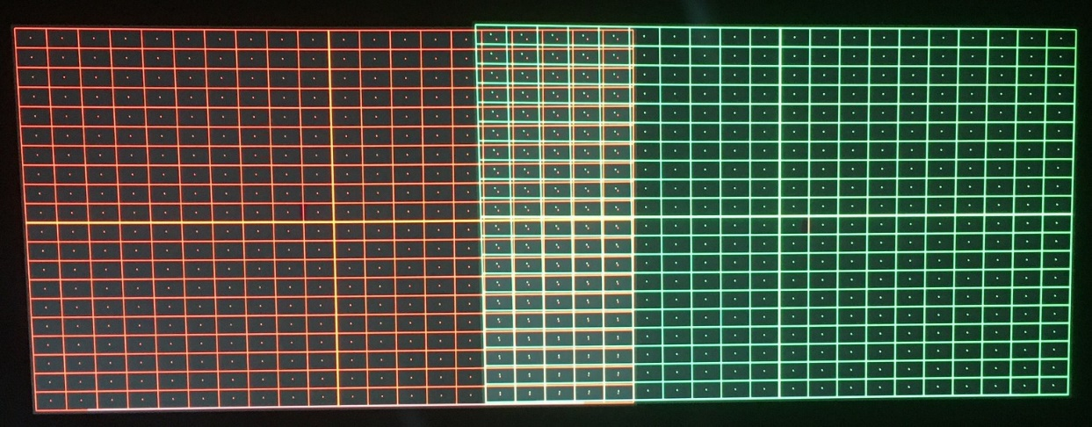
Before adjustment

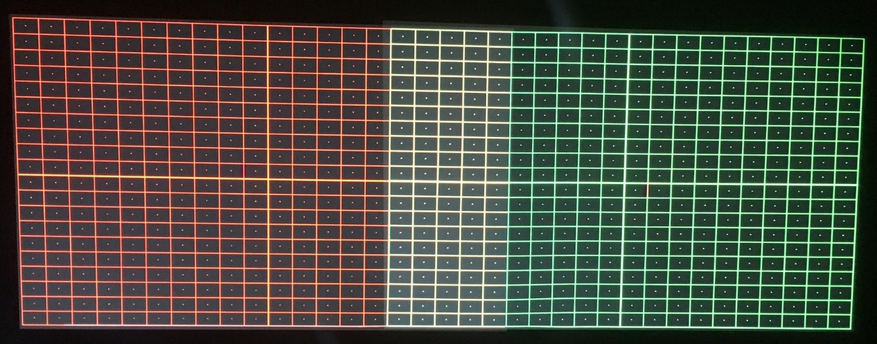
Adjustment finished

Edge Blending
1. Click on “Edge Blending” as shown below in the red box.
2. Enable the function, set the “Edge” position and the corresponding “Width” of the blending area. Press “Enter” to final the setting as shown below in the green box.
3. Enable the function and right click on the black box labeled as “Start”, “End” to
change the marker of the blending area as shown below in blue box.
4. Then the blending area is set as shown below in the cyan box.
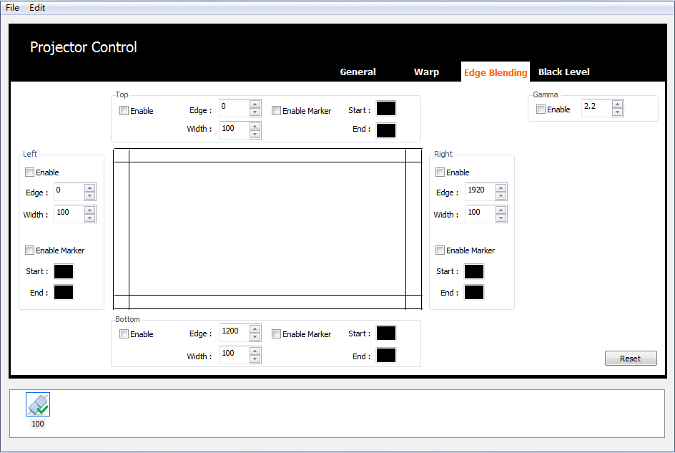
5. Input the Gamma value indicated in the purple box to control the gamma curve of the blending area.

Adjustment procedure:
※ Setting the blending width to get the edge blending marker superimposed on each other.
※ Whether the blending area matches each other depends on the result
of warping adjustment.
※ Set the same blending gamma value to the blending area of adjacent
projectors.

Enable Marker
Set the start position and the corresponding width to speed up the blending process
as shown below.

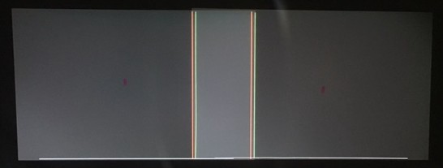
Before adjustment

Adjustment finished

Blending Adjustment for Multi Projectors

1. Please check projector's native resolution and input signal resolution.

2. Edge blending adjust width to match input signal segmentation.

3. Projector adjust ZOOM size and LENS offset for blending area overlap.

4. Warping fine-tune with Test Pattern function.

5. Enable Edge Blending and set same Gamma value for each projector.

Black Level
1. Click on “Black Level” as shown below in the red box.
2. Select “Enable” as shown below in the green box.
3. Select the control point, use【W】,【A】,【S】,【D】on the key board or simply
use mouse.

4. Use mouse to drag and put the control point to the desired position. Use
【⬆ 】, 【⬇】, 【⬅】, 【➔】on the key board to process fine tuning.

5. Set the color of the selected area. Click on the first row of the palette as shown below in the blue box.

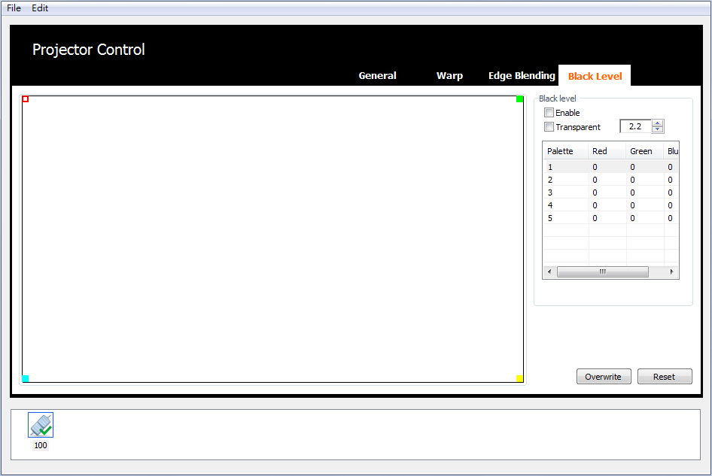
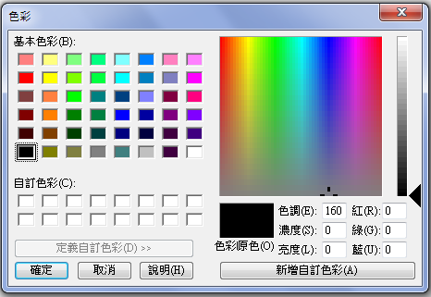
6. Click on “Overwrite” to apply the settings as shown below in the cyan box.

Save/Open

This function allows the user to save the current settings for each projector and open the setting for them after power on next time.
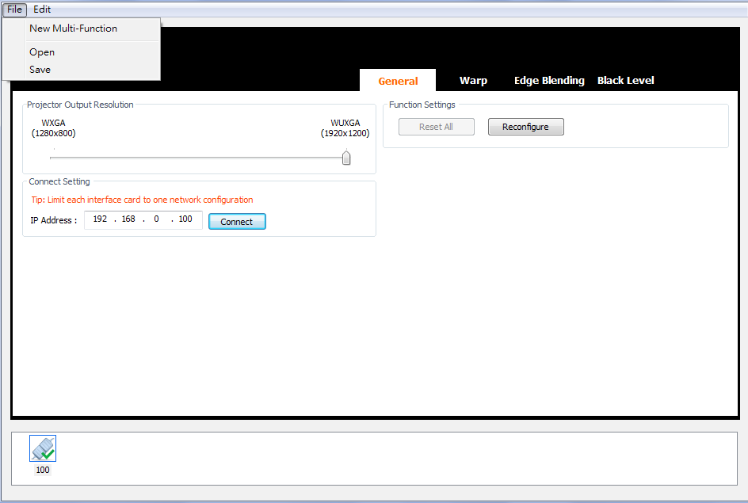
User can enable this function in the menu【File】→【Open】/【Save】.

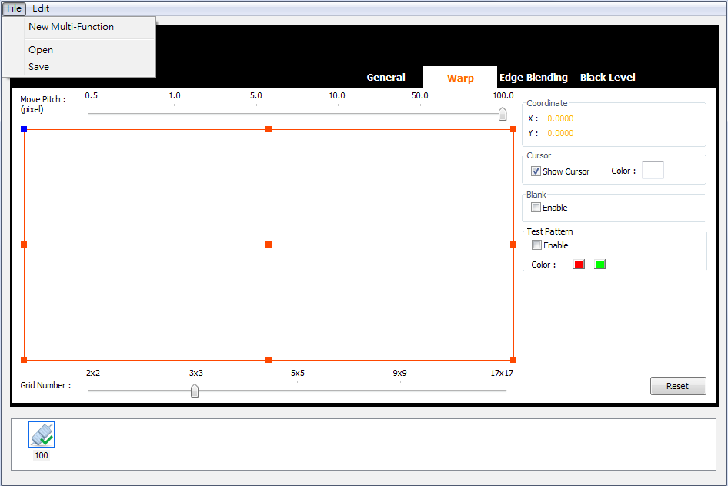
User can save all the settings after adjustment by clicking on【Save】.

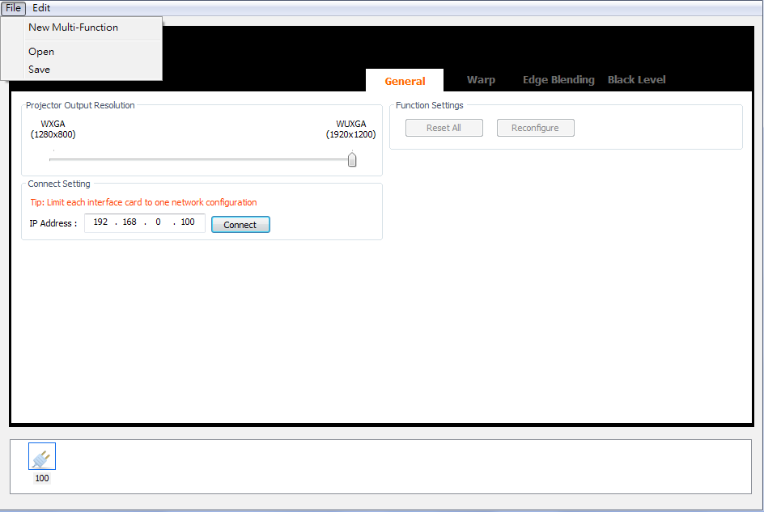

User can apply the previous settings by click on 【Open】.
1. Edit IP address and connect with projector.
2. Click on【Reconfigure】to apply the previous settings.

